Imagination in Action:
A Case of Hankyu Corporation and its Suburban Development in Japan, 1910-1939

Shuntaro Nozawa
PhD Candidate, Sheffield School of Architecture, the University of Sheffield

Modernity arose in association with industrialisation and, more importantly, with a gradual change in ways of life, and was thus intrinsically obscure. I am currently undertaking a PhD project, Modernity at Home, which, focuses on Japan in the period 1890-1939 and attempts to conceptualise the houses of ordinary people as subtle responses to this process. Suburbs form part of this enquiry into questions of modernity, because, as architectural historian Hiroyuki Suzuki (2005) has pointed out, one distinction between pre-modern and modern societies was the emergence of suburbia.

This paper draws on Modernity at Home, and explores the relationship between the imagining of everyday life and suburban built form, with particular interest in the system of values and family relations at a cognitive level. I examine the enterprise of Hankyu Corporation, created in 1910, a railway company based in an industrial city, Osaka. It opened up the first railway connected suburban estates for private home ownership in Japan, and its pioneering work was a stimulus for further developments led by competitors. Imagination in Action comprises social-anthropological analysis, with an ethnographical perspective to modernity, self-identity and material culture. Using Hankyu’s commercial literature from customer housing catalogues to the in-house newsletter, I will illustrate how the corporation understood suburbia and how it shaped the image of life for others in these new suburbs.

Hankyu as an aesthetic agent

According to Ichizō Kobayashi, a founder of Hankyu, suburban expansion was fuelled by the popularisation of leisure pursuits involving a trip to countryside among a growing number of the middle-class families. It was also related to urban deterioration, the worsening pollution levels within central Osaka and increased fears of epidemic diseases from an awareness of personal hygiene. Kobayashi’s endeavour to manipulate the decentralisation of middle-class consumption lay in a search for refined shumi (taste) made extensively by the cultural elites after the Russo-Japanese War of 1904-5. The protagonists of shumi espoused a view of Romanticism, and ascribed the vulgar ostentation that the nouveau riche exposed to a decline in aesthetic standards. The remedy for it, they believed, was to cultivate shumi (taste) through active involvement in appropriate shumi (recreations) at a personal level. As the cultural historian Jinno has argued (1994 [2011]: 26), the dual meanings of the Japanese term shumi originated from this cultural movement.

Kobayashi also attributed early-century materialism to the relatively new concept of home. ‘Home’ was the exposition of an alien tenet of family relations, but had become part of the knowledge of Japanese elites at that time. As well as Romantic commentators in the West, he conceived of it as a segregated domain from the unexpected public world and, in theory, as a sanctuary for refuge and pleasure. It would not be activated in practice, however, unless it strongly appealed to the consuming public as suburbanisation presumed a geographical separation of work and house thereby compartmentalising members of the family by sex and by age. The answer to this challenge of Kobayashi and supposedly the taste-makers of the period was that a variety of shumi (recreations) were offered not only as correctives of shumi (taste) as part of home ‘education’, but also as means to unite the whole family.

Hankyu’s business in the 1910s was indeed a direct response to the quest for shumi. Its monthly magazine Sanyō-suitai, published between 1912 and 1917, urged the readers to admire the changing seasons and rustic scenery through gardening, strolling and visiting local festivals. This quasi-didactic periodical served as an event calendar that ordered kinds of recreational activities according to the seasons. To display what was appropriate in aesthetic standards and forms of recreation, Kobayashi was also involved in the debut of a girls’ operetta at a Hankyu spa resort and in the construction of a full-scale ballpark situated in its estate.

Family and Home

During the 1910s, three housing estates targeted at middle-class households were built by Hankyu. Houses erected in the estates were designed based on the “family-oriented” principle, purpose-built and planned with family life compartmentalised. This was distinct from the domestic interiors of traditional architecture which were characterised by an open-plan arrangement of interconnected spaces. Here, the interior was no longer en suite and each room was sectionalised by means of corridors (Figure 1). Yet a room close to the kitchen, as a short story of Sanyō-suitai indicated (X 1913), was expected to be multi-functional and used as a dining room and sitting room. This communal space, as many commentators on Japanese history have discussed, became widely recognised as a sign of family gatherings at ‘home’.

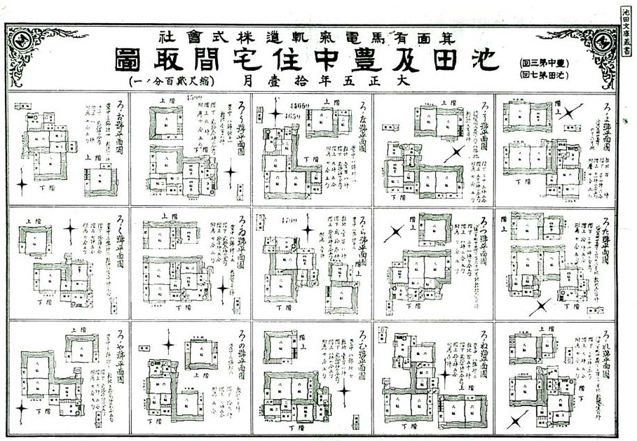
Figure 1
“Floor Plans of Houses in Ikeda-Muromachi and Toyonaka estates.” Housing Catalogue 1916. Ikeda Bunko Library, Ikeda.

An epistemological connection of such a newly acknowledged view of family life with a growing awareness of public health is expressed in this configuration of lifestyle. There was careful consideration of sun path and ventilation and the rooms serving as living spaces were oriented to the south in accordance with scientific prescriptions. The shape and exterior evoked those of vernacular architecture as part of the symbolism of power under the feudal control (Figure 2). Building materials however did not mean anything more than practicability. Hankyu’s houses were covered up by weatherboards, to cool room temperatures during the summer months.

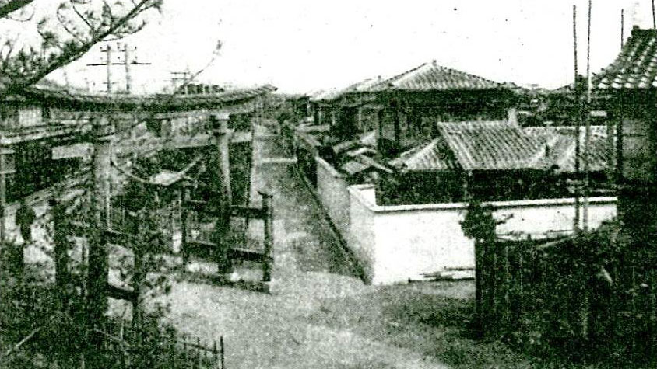
Figure 2
View from a street in Ikeda-Muromachi estate (X 1917b).

Without the garden, a suburban house lost much its raison d'être. It is possible to consider that such a domesticated ground was intended to be a place where members of the family cultivated their shumi and their interfamily relationships. The monotonous landscape of the estates framed by the quadrilateral networks of roads embedded a civilising message into everyday life (Figure 3). Over the fences, the large garden was regularly placed on the south side of each plot. This privilege of suburbia for leisure experience promised healthy bodies and shumi – in both taste and recreations – of the middle-class families.

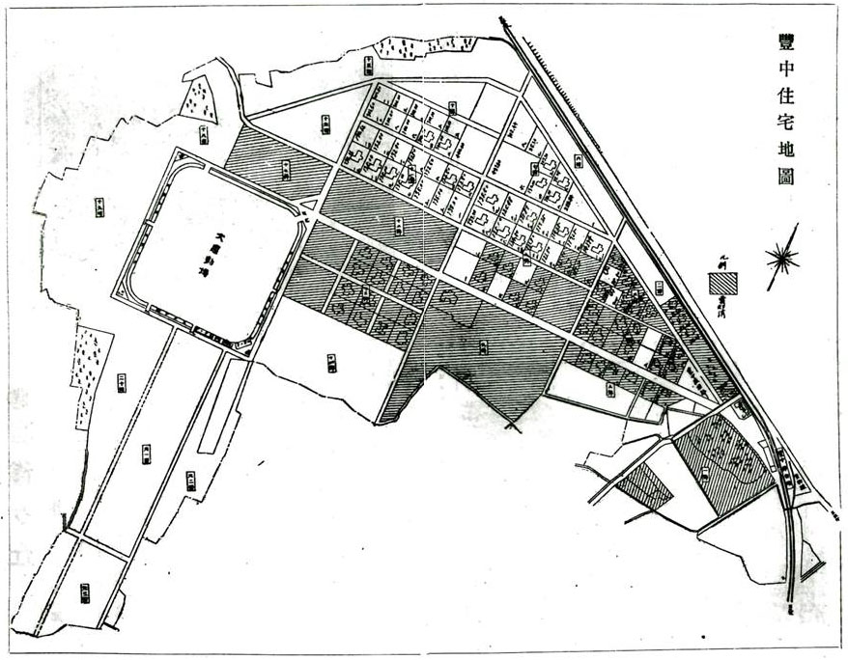
Figure 3
“Map of Toyonaka estate” (X 1917a).

The era of modernists and Hankyu

Hankyu’s housing developments became extensive over the next two decades and were favourably affected by the social and political climate of the Wars. A series of the battles had enlarged the urban population, and the worsening state of urban tenements led the Japanese elite to start considering quality of life. In 1922, the Housing Reform Exhibition was held near the Hankyu owned Minō station, luring the crowds with an array of exotic model houses ranged along curvilinear roads. These were the fruits of architects’ attempts to make a more rational cultural life and the experiment was closely associated with a government-led campaign for the simplification of daily life. It aimed to seek ways in which both labour productivity and the rationality of rituals could be enhanced in preparation for future military campaigns. Hydroelectric power was then largely promoted, allowing Hankyu to enlarge its scope of business. It extended the railway in 1920 and was involved in the construction of thirteen new residential estates.

Houses of the Hankyu in the 1920s and 1930s were uniform in planning. These were categorised as an interior-corridor plan which was largely seen between the Wars (Figure 4). A corridor running from east to west was the hallmark of this unique interior, dividing rooms used for eating, sleeping and family gatherings in the south from service spaces including the kitchen, guest room and servants’ room. This standardised domestic architecture was in many cases wrapped in a set of building materials that looked like traditional Japanese architecture (Figure 5). Some however were in Occidental guises, such as Spanish Colonial and Tudor Gothic architecture. Under the banner of simplification, the confidence of Hankyu’s architects was boosted by the modernists’ emphasis on the ahistorical, systematic view of things. In fact, houses dressed with Le Corbusier and, Bauhaus-like motifs were erected in the estates of the early-1930s (Figure 6).

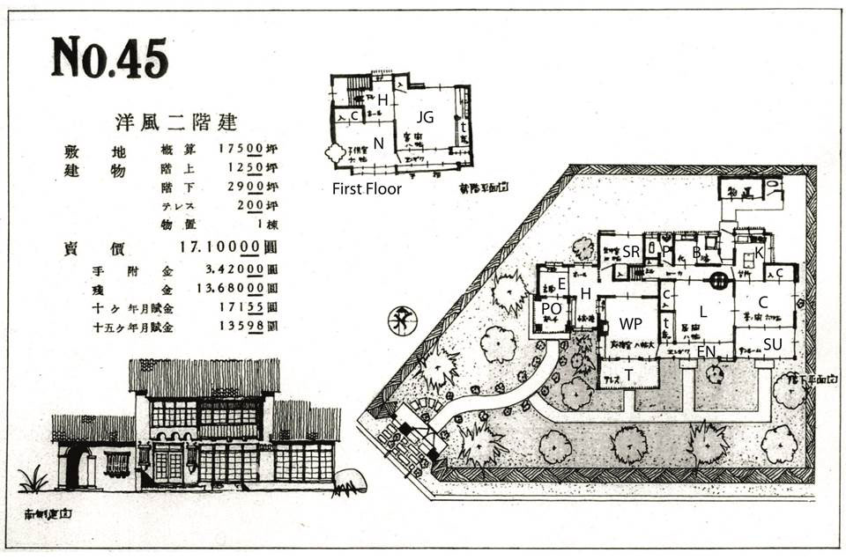
Figure 4
Floor plan and exterior of a house in Mukonosō estate (B: Bathroom, C: Chanoma, E: Entrance, EN: Engawa, H: Hall, JG: Japanese-style guest room, K: Kitchen, L: Living room, N: Nursery, P: Privy, PO: Porch, SR: Servants’ room, SU: Sunroom, WP: Western-style parlour, c: Closet, t: Tokonoma alcove). Housing catalogue of Mukonosō estate c. 1937. Amagasaki Municipal Archives, Amagasaki.

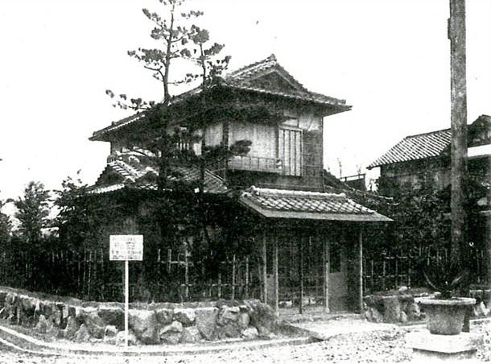
Figure 5
Exterior of a House in Sonoda estate. Housing catalogue of Sonoda estate c. 1936. Amagasaki Municipal Archives, Amagasaki.

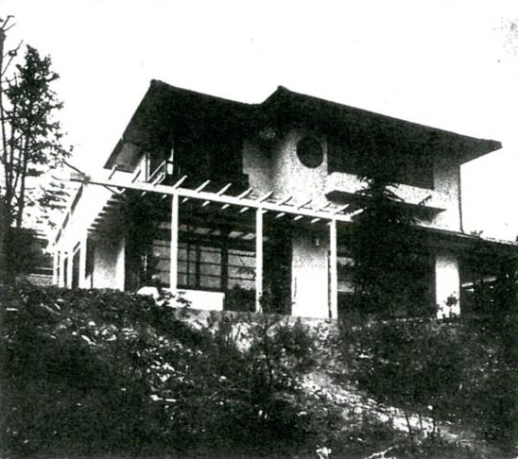
Figure 6
Le Corbusier influenced house in Higashi-Toyonaka estate. Housing catalogue of Higashi-Toyonaka estate c. 1933. Amagasaki Municipal Archives, Amagasaki.

By no means did these adhere to a Modernist doctrine. The Hankyu buildings contained implicit narratives framed around a notion of domesticity that the modernist architects had consciously abandoned (e.g. Wilson 1991, 96). A quotation from Victor Hugo printed in Hankyu’s in-house newsletter was indeed representative of the shumi that both its architects and their clients had: “‘A refuge from danger,’ which a French poet Hugo discovers at home, has become a principle of designing a humble house; such a peaceful dwelling manifests a sense of comfort and enjoyment, as opposed to a French architect Corbusier’s machine à habiter” (X 1934).

In short, Hankyu’s engagement in imagining the suburbs were carefully accorded with shumi in both taste and recreational pursuits, bracketing what Anthony Giddens had defined as a source of “ontological security” for a new social group – the middle classes – in line with the Romantic fantasy (1992[1991]: 36). For Hankyu’s architects, the picturesque amenities, including tree-lined boulevards and radius junctions, were communal spaces and part of arena to which family life was extended (Figure 7 and 8). Small parks and decorative flower beds were elaborately positioned, as subtle associations that promoted pastoral shumi in everyday life.

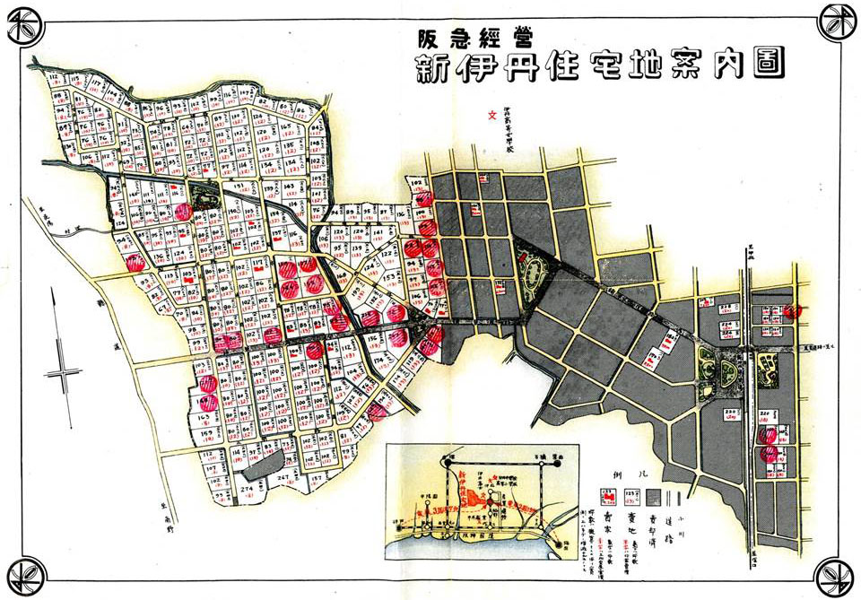
Figure 7
“Map of Shin-Itami estate.” Housing catalogue of Shin-Itami estate c. 1935. Amagasaki Municipal Archives, Amagasaki.

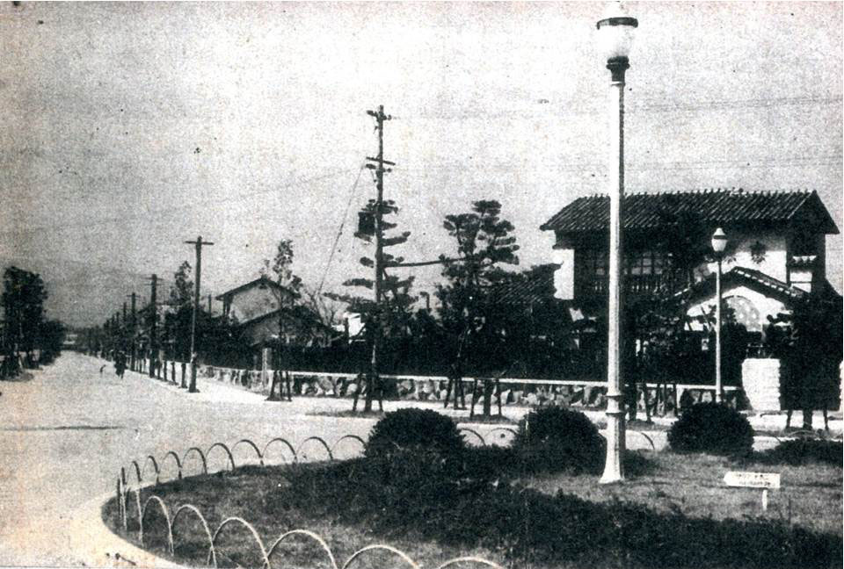
Figure 8
Boulevard and roadside trees in Mukonosō estate. Housing catalogue of Mukonosō estate c. 1937. Amagasaki Municipal Archives, Amagasaki.

(Numbers of words: 1,482)

Reference

Giddens, A. 1992 [1991]. Modernity and Self-Identity: Self and Society in the Late Modern Age. Cambridge: Polity.
Jinno, Y. 1994 [2011], Shumi no tanjyō: Hyakkaten ga tsukutta teisuto. Tokyo: Keisōshobō.
Suzuki, H. 2005. “Kindai toha nanika.” In Hiroyuki Suzuki, Osamu Ishiyama, Takeshi Itō and Tsuneto Yamagishi (eds) Kindai toha nanika, pp. 1-19. Tokyo: University of Tokyo Press.
Wilson, E. 1991. The Sphinx in the City: Urban Life, the Control of Disorder, and Women. London: Virago.
X. 1913. “Bokuno jyūtaku.” Sanyō-suitai (December 1913): 5.
X. 1917a. “Toyonaka shin shigai.” Sanyō-suitai (August 1917): 9-11.
X. 1917b. “Risōteki den-en-toshi Ikeda shin shigai.” Sanyō-suitai (August 1917): 16.
X. 1934. “Kensetsu jyūtaku zu dai 12.” Hankyu shahō no. 189 (15 September 1934): 14.

